Agenda

Dates
Cost
Roster
Contact Info and Updated Sheet
Mail for Scouts
Cell Phone/ Electronics
Swim Test
Medical Forms and Support
COVID Particulars
Camp Security
Emergencies at Camp
Camper Problems
Food and Snacks and the Trading Post
Scouts BSA Specifics
Campground Map
Merit Badge Classes and Activities
Shenandoah Olympics
Clothing and Uniforms
Equipment and Gear
Drivers
Detailed Timeline
Troop Equipment

BSA TROOP 20
SUMMER CAMP

Dates:
July 10 – July 16th (BSA Week 3)

Cost
- Registration:
- Pre-camp equipment (expenses should be minimal)
- Daily spending money: no more than $5/day recommended
- All Merit Badge fees are included in the camp fee
- Friday classes: $20 - $40

Roster
- Please check the roster to make sure I have all your correct information

Contact Information
Leaders’ Contact Information:
Peggy Melloy : 757-634-9628
Kay Dee Kline: 757-243-4258
Sara Oubre: 225-993-1157
Rachel Sampson:

Camp Shenandoah Phone (front desk): 540-886-7513
Mailing Address:
Camp Shenandoah
222 Boy Scout Lane
Swoope, VA 24479

Mail for Scouts
- Pre-written mail will be collected at the drop off location.
- Please put letters in a manila envelope with your scout’s name on it.
- You can add what days you would like to have the mail delivered.

Cello Phone/Electronics
- Must be left in the car, not allowed in the camp.
- Cameras are allowed
- Parents can contact their scout via a SM or the camp front desk.

Swim Test
- Jump feet first into deep water, swim 75 yards using: sidestroke, breaststroke, trudgen, or crawl; then 25 yards using elementary backstroke. Rest by floating.
- Most of the troop is tested, but be prepared to test
- All scouts and leaders should be prepared to test on Day 1, at arrival. Leaders who refuse to test will not be allowed in the aquatics area

Medical Forms and Support This is a No-Exceptions Event
- All portions of the medical form must be completed, signed by a doctor (Part C) and in hand prior to departure. Applies to anyone staying over 72 hours. (Under 72 hours, A, B1, B2) with insurance card
- Must be the current form! Not an old one, not last years.
- 24-hour Health Lodge on site for general sick call; Urgent and Emergency Care in Fishersville, VA
- Medications must be checked in with troop leadership before departure, in a ziplock bag with special instructions, and with a Medical Responsibility Form
- If the health form says the scout needs an inhaler or epi-pen, the scout must have it with them.

Virginia Headwaters Council Recommended Covid-19 Guidelines
Several counties and communities in our council are reporting HIGH community transmission levels of Covid-19. Our efforts center upon mitigating opportunities to spread the virus.
- For unit, district and council activities: units are to check their Covid-19 Community Transmission level prior to any indoor activity or meeting.
- In areas that are HIGH (Orange), participants should return to masking indoors at all times. Outdoor activities remain acceptable without masks.

Current guidance for Camp Shenandoah. Our Council Covid-19 Response Team recommendations:
- OA June Inductions, June 3 – 5: masking in the Dining Hall when not eating, in the Trading Post and Health Lodge. You do not need to wear a mask outside, in a campsite or during OA ceremonies.
- Summer Camp: we will update any protocols for summer camp on June 15.
- We encourage all guests to update their Covid vaccinations on their Annual Health & Medical Record (AHMR).
- As transmission levels continually modify, we will update visiting units of our policies one week prior to arriving at camp.
- Council policies and procedures are be reviewed and updated on the 1st and the 15th of each month by our Covid-19 Response Team.
- If you have any questions, please contact us by email at scott.lancey@scouting.org

Camp Security
- All campers must wear a wristband
- Visitors and leaders coming in and out must sign in at the front office (emergency only)
- Staffs wear name-badges
- Buddy systems will be used at all times.

Emergencies at Camp
- Personal emergencies will be handled by the adult leadership as appropriate
- Environmental emergencies: siren, move to a shelter area, get accountability
- Extreme heat – activities will slow down
- Wildlife encounters - #1 keep your distance; #2 report to the ranger
- Lost Camper – Accountability drill, then shelter and accountability, then search
- Lost swimmer/ boater – All units will move to the parade field to conduct accountability

Camper Problems
- Homesickness
- Didn’t bring the right gear
- Ran out of money
- Can’t make it to places on time

- If a scout needs to leave early, an “Early Release” form needs to be completed.

Food and Snacks and the Trading Post
• There is plenty to eat in the mess hall – no one will go hungry
• The trading post has patches, scout craft materiel, clothing, and snacks
• A scout is thrifty

Scouts BSA Specifics
• All YPT must be followed (no one-on-one, two-deep leadership, registered and trained leaders.)
• Shower house has separate and securable entrances for youth, adult, male, female.
• Buddy system at all times; if mixed gender, then three scouts at a time
• No restrictions on any activities

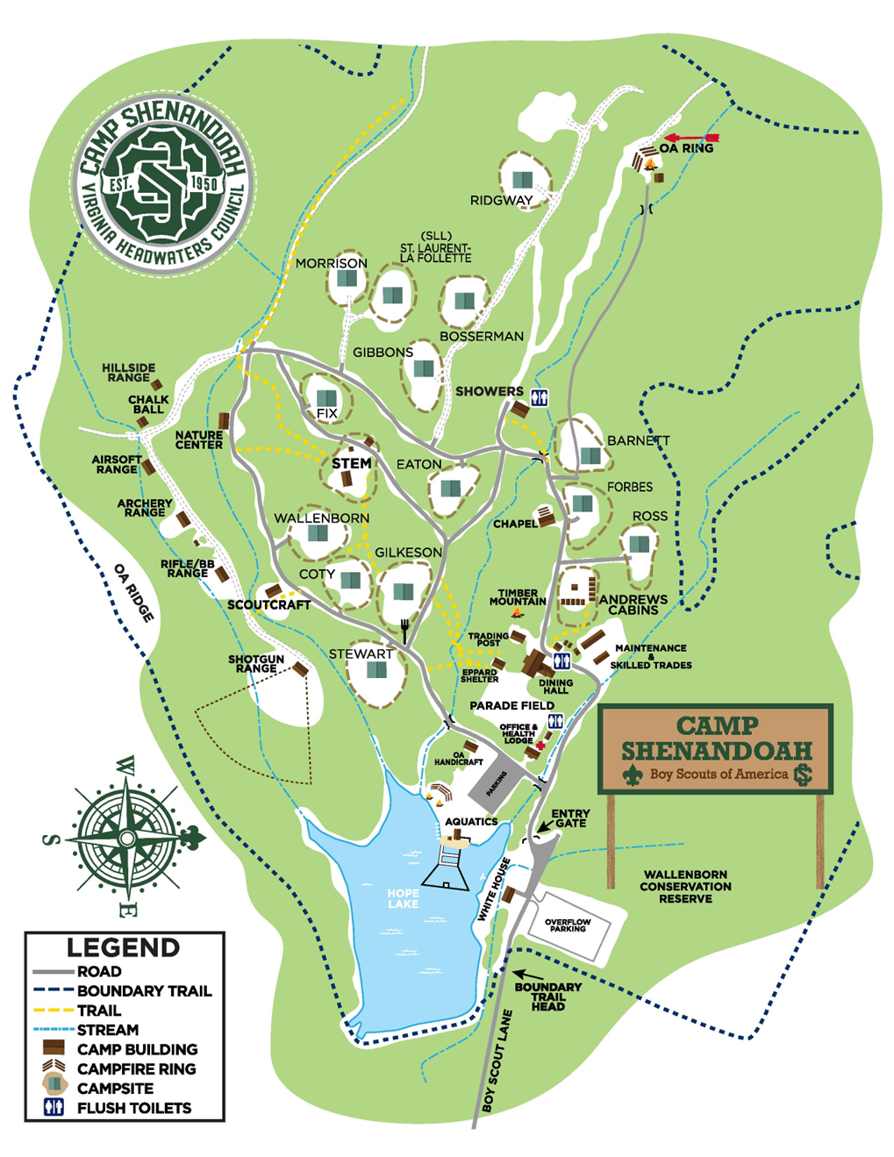

We have requested following: Eaton, Barnett or Ross

Merit Badges and Activities
- Pay attention to pre-reqs. Some are extensive and some are minimal.
- Scouts, it is your responsibility to complete your pre-reqs.
- Scouts who don’t complete merit badges will leave camp with a “partial”. It is then their responsibility to contact a counselor and complete the merit badge.
- Merit badge classes are scheduled Mon-Thurs.
- Friday classes are special activities.

Shenandoah Olympics and other Activities:

- Olympics:
Dessert Cook-off Rifle Shoot
Tug-a-war Archery Shoot
5k Run Muzzle Shoot
Fire building

- Awards: Honor Troop, Neptune Society, Inspection, Scoutmaster Merit badge, Aquatics Associate, Range Associate
- Pioneering competition, open shoots, open swim, fishing, polar bear swim, trading post, gaga pit.
- Friday: Aquapalooza, terrapalooze

Clothing and Gear
Go to Troop Website for more detail on mosquito nets or footlockers

ESSENTIAL ITEMS
• Completed “BSA Annual Health and Medical Record” signed by parent or guardian and physician (Parts A, B & C) with a copy of the participants medical insurance card.

• Full BSA Field Uniform (Class A) which include shorts or pants.
This uniform is worn at evening flags/dinner, campfires, Vesper service & OA activities.
• The activity uniform (Class-B shirt) is the preferred daytime attire.
• At least seven pairs of socks (some Scout socks for use with summer uniform).
• Neckerchief (an option of troop uniform requirements).
• Towels (2) and washcloth.
• At least six changes of underwear.
• Swimming trunks or swimsuit.
• Sleeping bag or sheets and blanket.
• Poncho or raincoat – A MUST!
• Extra pair of shoes (for wet weather) – A MUST!
• Duffel bag or footlocker
• Soap, toothbrush, toothpaste, and comb.
• Flashlight with extra batteries.
• Your Scout Handbook.
• Notepaper, pencil or pen.
• Canteen or water bottle – A MUST!
• Money for Trading Post and any optional Merit Badge supplies.

OPTIONAL ITEMS
• Camera.
• Compass (required for some Merit Badges).
• Pocket knife with Totin’ Chip card.
• Fishing pole and tackle (Do not bring live bait – camp will have available for purchase).
• Backpack and backpacking tent (if needed for specific merit badge requirements).
• Personal cooking utensils (if needed for specific merit badge requirements).
• Hiking boots (if needed for specific merit badge requirements).
• Permanent marker to write your name on items that easily get lost.

PROHIBITED ITEMS
• Sheath or butterfly knives (or other knives designed for defense/tactical)
• Firearms, including archery equipment (unless approved for use by those with special needs)
• Fireworks of any kind including “poppers”.
• Laser pointer.
• Illegal substances including alcohol or any vaping liquids or equipment.

Drivers
We will need drivers on the outbound and the return

Detailed Timeline
Sunday, July 10th

9:00am Meet at Wal Mart parking lot (Lightfoot) for check-in
▪ Medication drop-off
▪ Medication form check
▪ Mail drop-off
▪ Gear load in trailer
9:45am Start Driving
11:30am 30min lunch break
1:00pm Arrive at Camp Shenandoah

Troop Equipment
◻ Gear trailer
◻ Medical Forms
◻ Council Medical Insurance
◻ Cleaning Supply box
◻ 2x cast-iron pots
◻ 2x propane lantern
◻ 2x Propane cans with posts
◻ Paper plates, bowls, cups, flatware for troop cook night
◻ Clock
◻ Butcher block pad w/ markers
◻ Troop sign
◻ Troop flags
◻ Ax/ chopping circle equipment
◻ Pioneering Poles
◻ Knot/ Lashing Ropes
◻ Merit badge library

